Powys War Memorials Project
2014-19: A Mark of Respect

News from project 2017

Powys War Memorials Project 2018 competition.....

December 15, 2017
Watch this space !
​
The Powys War Memorials Project Officer organises a competition each year. The 2016 competition was a war memorial photography competition and the 2017 competition was a quiz.
​
Watch this space for details of the 2018 competition....
​
​

"Go and See" First World War Commemoration Activity funding for schools

December 13, 2017
From 11 November 2017 Go and See funding will also be available for schools to access creative experiences for their learners, as part of a meaningful educational activity relating to First World War commemoration.
​
Schools can apply for up to £1,000 at any time in the year and will receive a decision within three weeks. We will award 100% of the costs of the experience. Schools are not required to match-fund.

Go and See funding for schools

"Men on the Gates": The lives and stories of the men commemorated on Oswestry War Memorial Gates

December 11, 2017
Oswestry Community Action, otherwise known as Qube, is a registered charity based in Oswestry.

In 2016, Qube was awarded funding by the Heritage Lottery Fund (HLF) to research and record biographic details of the fallen men who are listed on the Oswestry War Memorial, sited at the entrance to Cae Glas Park.
​
The project aims to uncover civilian and military information for each of the men listed on the pillars, enabling each of their unique stories to be told as completely as possible and interpret their lives and sacrifice in the context of ‘Oswestry’ and ‘The Great War’.
​
"Men on the Gates" project website

Men on the Gates project website

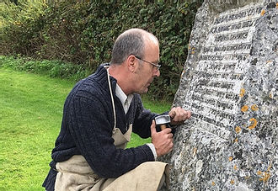

Case study: Restoration of war memorial in Old Radnor, Powys

December 08, 2017
The war memorial in Old Radnor (Powys) received a repair grant of about £1000 from the Powys War Memorials Project.
Here is a case study about the war memorial in Old Radnor.
​
Old Radnor war memorial case study
​
​

The Flying Bridge Theatre Company are delivering World War 1 workshops in residential care homes in Powys

December 05, 2017
The Flying Bridge Theatre Company are delivering workshops, based on their World War 1 production "Between the Crosses", in residential care homes in Powys for the Powys War Memorials Project.
​
Several workshops have taken place so far. More workshops are due to take place in the coming weeks.
​
During the workshops, the Flying Bridge Theatre Company perform excerpts of their World War 1 production "Between the Crosses" to stimulate discussion among the residents and clients about war, conflict and remembrance.

Some residents and clients have shared personal stories about how members of their family were affected by World War 1; others have given unique insights into their local war memorials. For example, one resident explained that the statue of the war memorial in Llandrindod Wells was modelled on a local young man called Jack....
​
​

Please contact the Powys War Memorials Project Officer if you would like more information about the workshops.
​
​
​
​

Flying Bridge Theatre Company

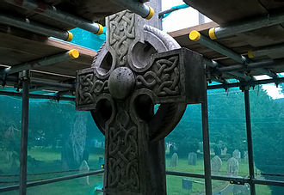
Restoration of Llansilin war memorial underway!
November 22, 2017
The restoration of the war memorial in Llansilin (north Powys) is underway !
​
The Powys War Memorials Project is funding 90% of the total cost of the work (about £4,000). The rest of the funding is coming from St Silin's church in Llansilin and Llansilin Community Council.
​
The memorial is being cleaned and some repointing is being carried out. In addition, the inscriptions (including all the names) on the memorial are being repainted.
​
Church Secretary Valerie Burton had the explanation: “The War Memorial is having a makeover!
With help from the Community Council, the Church Council has taken advantage of funding from Powys County Council to take part in a County-wide project. All communities have the opportunity to spruce up their memorials ready for the nation’s commemorations in November 2018.”
​
Please contact Nathan Davies, Powys War Memorials Project Officer, for more information about the repair grants available for World War 1 memorials in Powys.
​
​
​
​

"Between the Crosses" World War 1 play performed by Flying Bridge Theatre Company at Welfare in Ystradgynlais

November 20, 2017
The Powys War Memorials Project was delighted to have provided funding for the Flying Bridge Theatre Company to perform the World War 1 play "Between the Crosses" at the Welfare in Ystradgynlais on Friday 17th November 2017.
​
Many thanks to the Flying Bridge Theatre Company, the Welfare in Ystradgynlais and everyone who came to the performance.
​
​

Short clip of "Between the Crosses" performed by Flying Bridge Theatre Company

Free online map of World War 1 memorials in Powys

November 17, 2017
The Powys War Memorials Project has worked with the Living Legacies programme to develop a free searchable online map of World War 1 memorials in Powys.
​
Map of World War 1 memorials in Powys
​
Please contact Nathan Davies (Powys War Memorials Project Officer) if you know about any World War 1 memorials in Powys that are not on the map. We are also always grateful for any information, photographs or even video clips of World War 1 memorials in Powys.
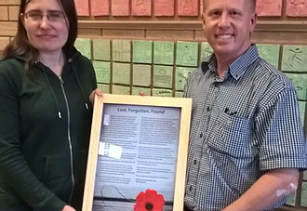
"Lost, Forgotten, Found" by Frances Marshall
November 15, 2017
The Powys War Memorials Project Officer would like to thank Frances Marshall for writing the article "Lost, Forgotten, Found" about war memorials in Llandrindod Wells, Powys.
​
"Lost, Forgotten, Found" by Frances Marshall (July 2017)
​
The Powys War Memorials Project Officer presented Frances with a framed copy of her article yesterday.
​
​
​

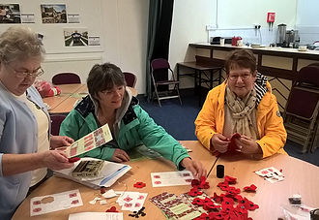

Poppy-making workshop
October 16, 2017
​
The Powys War Memorials Project would like to thank everyone who came to the free poppy-making workshop at the Welfare Ystradgynlais yesterday.
The workshop was delivered by Wonderwool Wales.
People at the workshop made textile poppies for the Curtain of Poppies. The Curtain of Poppies will consist of 887,858 textile poppies. The poppies will commemorate each person from the UK who died during World War 1.
The aim is to display the Curtain of Poppies at the Wonderwool Wales festival in 2018.
Thanks again to everyone who came to or helped with the event.
​

Curtain of poppies

Imaging the Bible in Wales database

October 12, 2017
The Powys War Memorials Project would like to thank the Imaging the Bible in Wales project for their support.
​
Biblical Artwork from Wales 1825–1975
​
The images included in this on-line collection have been collected as a research database for the Imaging the Bible in Wales Project (2005-8).
​
Many of the images were photographed specifically for the project and include artworks from places of worship in Wales. In addition, further images have been included from public and private collections.

Search the Imaging the Bible database here

Free poppy-making workshop: Monday 16th October 2017, 10am-5pm (drop in), Welfare hall, Ystradgynlais, Powys

October 10, 2017
Free poppy-making workshop
​
Monday 16th October 2017
10am-5pm
Drop in session with no booking needed
Welfare Hall, Ystradgynlais, Powys
​

Information about free poppy making workshop

Talgarth (near Brecon) QR code World War 1 walk

October 08, 2017
The Powys War Memorials Project has worked with History Points to create a QR code walk for the World War 1 walk around Talgarth near Brecon (Powys).
​
Link to Talgarth World War 1 QR code walk information
​
The First World War took a heavy toll on Talgarth, where the local war memorial lists 25 men who died. Two days after war broke out, a meeting was held at the town hall to encourage local men to enlist. About 20 young men rushed forward to give their names.
​
By 1915 the school headmaster’s roll of honour listed 95 of his past pupils who were serving in the war. Two men who were known and respected locally as preachers were killed. One had been rejected by the army several times because of a childhood leg injury but he eventually got his way, and was killed only a week or so after reaching the Western Front.
​
Talgarth’s postman was quick to enlist. His bravery on the field was rewarded with the Military Medal but he died in 1917. Side by side in Talgarth’s churchyard are the war graves of a brother and sister.
​
Now you can discover how the war affected Talgarth by following our self-guided trail. Simply scan the QR codes with your smartphone at any of the featured places to start. When you’ve read the text for that location, click “Next” to see the text and map for the next place on the trail. Eventually you’ll return to your starting point.
​

Talgarth World War 1 QR code walk information

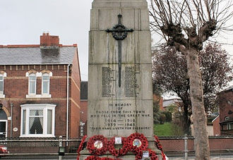

Newtown Remembers

October 04, 2017
The Newtown Remembers partnership, led by Newtown Town Council is leading a project to commemorate the impact of the First World War on the town.
Activities during 2015 included free trips for local people to visit exhibitions, museums and the National Memorial Arboretum in Stafford and then use these experiences to highlight how Newtown and the local population were affected by the war.

Newtown Remembers project website

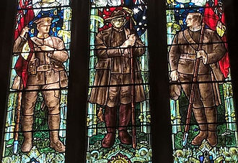

Holy Trinity Church, Llandrindod Wells

October 02, 2017
If you're in Llandrindod Wells (Powys), the Holy Trinity Church is well worth visiting. There are several World War 1 memorials in the church, including a memorial chapel and this memorial stained glass window.
​
​

FREE POPPY MAKING WORKSHOP !!
September 28, 2017
FREE POPPY-MAKING WORKSHOP
Monday 16th October 2017
10:00am - 5:00pm
The Welfare, Ystradgynlais, Powys
Free refreshments
Everyone welcome
No booking needed
Would you like to come to a free workshop, delivered by Wonderwool Wales, to make a textile poppy for the Curtain of Poppies?
The Curtain of Poppies will consist of 887,858 textile poppies. The poppies will commemorate each person from the UK who died during World War 1.
The aim is to display the Curtain of Poppies at the Wonderwool Wales festival in 2018.
http://www.wonderwoolwales.co.uk/sh…/curtain-of-poppies.html
Funded by the Powys War Memorials Project:
www.powyswarmemorials@powys.gov.uk
Grants of up to £5,000 to repair or restore World War 1 memorials in Powys
September 14, 2017
Grants of up to £5,000 to repair or restore World War 1 memorials in Powys
The Powys War Memorials Project can provide grants of up to £5,000 to repair or restore World War 1 memorials in Powys.
- Any type of war memorial is eligible, e.g. obelisks, crosses, stained glass windows, boards or benches.
- World War 1 memorials with World War 2 additions are also eligible.
- Grants are also available to improve war memorial settings or surroundings, e.g. railings, gates or lighting.
- Allocating grants on a first come, first served basis so advisable to apply as soon as possible.
- Application process is quick and easy.
Please contact the Powys War Memorials Project Officer for more information:
Warmemorials@powys.gov.uk
07973 973 687

Email the Powys War Memorials Project Officer

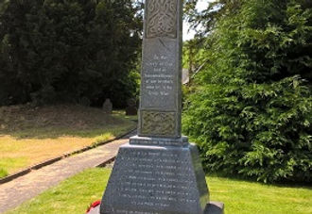
World War 1 memorials in Powys
September 07, 2017
One of the outcomes of the project is to find, record and map all the World War 1 memorials in Powys.
​
We currently know of about 350 World War 1 memorials in Powys. Here is a list of the memorials that we currently know about:
​
World War 1 memorials in Powys
​
If you know about a World War 1 memorial in Powys that is not on the list, please contact the Powys War Memorials Project Officer (warmemorials@powys.gov.uk). Similarly, if you notice that any of the information about a war memorial is incorrect or if you have any other information about a war memorial (including photographs), please contact the Powys War Memorials Project Officer.
​
It has been suggested that there could be about 1000 World War 1 memorials in Powys. In other words, it is likely that we do not yet know about all the World War 1 memorials. Why is this? Some memorials may have been located in hospitals or schools that have since closed down; others may have been in places of work that moved premises.

Email the Powys War Memorials Project Officer about a memorial in Powys

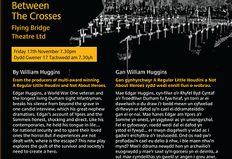
FREE World War 1 play "Between the Crosses": Friday 17th November 2017, 7:30pm, Welfare Ystradgynlais, Powys
August 23, 2017
Between the Crosses
By Will Huggins
Flying Bridge Theatre Company
​
FREE ENTRY (booking required)
Friday 17th November 2017
7:30pm
The Welfare Ystradgynlais (Powys)
​
Funded by the Powys War Memorials Project.
​
Edgar Huggins, World War One veteran and the last surviving member of the Durham Light Infantry, gave an incredible audio interview to the Imperial War Museum in the 90’s about his life and wartime exploits. Now, his great nephew Will unpacks and stages the interview using his own memories, family memories, military records and furiously drawn diagrams on a huge blackboard, to try and find the hidden truths buried by a sense of duty and terrible trauma.
​
Edgar talks about how he joined up wanting to work with horses, but found himself on the frontline. The accounts of Ypres and the Somme are honest, shocking and direct, while the story of his relationship with his trusty horse “Captain” is heart-warming and moving.
Like so many veterans of the Great War in life Edgar held his tongue for national security and to spare his family the horror, but in this entertaining, moving and informative production, the full true story is laid bare, for the first time…..
​
Please visit the Flying Bridge Theatre Company's website for more information about the play:

Flying Bridge Theatre Company

Would you like some *free* training like Llangammarch Wells History Society?
August 23, 2017
The Powys War Memorials Project funded free website development training for members of the Llangammarch Wells History Society.
​
The main aim of the training was to provide members of the History Society with the knowledge, skills and confidence to update and maintain their website.
​
Here is a direct link to the World War 1 pages of the History Society's website:
​
Llangammarch Wells History Society World War 1
​
Sue Lilly, Chairman of the History Society, provided a summary of the training.
​
Please contact the Powys War Memorials Project Officer for more information about the free training available through the project.
​
​
​
​
​
​
​
​
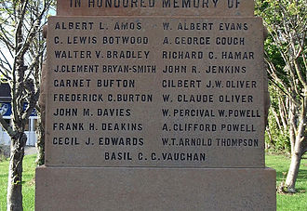

"Lost, Forgotten, Found" by Frances Marshall (16th July 2017)

August 06, 2017
Frances Marshall, a volunteer with the Powys War Memorials Project, wrote this emotive article about war memorials in Llandrindod Wells, Powys:
​
Lost, Forgotten, Found
​
What is a memorial? If someone had asked me that question eight years ago I’d probably say a statue with some names and words inscribed on it, recording people long gone from this world. Shadows trailing behind us, the nagging thoughts at the back of our minds, ghosts, who wail from beyond the grave, hoping for us to listen to their stories. And why should we? Sadly, that is what most of my generation of internet-dependents probably believe as well.
​
When I first volunteered to help the project locate and record memorials, I wasn’t sure what to expect. Llandrindod Wells is a small town and the only memorial I had been aware of was the one standing near its centre.
​
So imagine my surprise when I was informed there were possibly eighteen memorials in Llandrindod rather than one, all waiting for me to find them.
​
I guess there is a good side to technology after all.
​
To date, I have learned memorials can come in a variety of forms; brass plaques, stone obelisks, wooden Rolls of Honour and can be located in even the most obvious and sometimes overlooked places such as community churches.
​
Personally, I find it unfortunate to see the past hidden in a place of sanctuary. But then again where does one go when you are forgotten?
​
Of all the memorials I have seen so far, the planted oak trees at The Lakeside, the war graves in the town’s cemetery and the cenotaph outside Llandrindod High, I found the stained glass windows in Trinity Church the most outstanding, not simply because of its enlightening display, but for its metaphorical representation. It is fragile like the bodies of the soldiers as they clambered over the trenches, avoiding bullets and missiles. Yet, it lets in the light and stands as a protection against the terrifying truths of the world. The colours; pieces of the souls reassembled by the hands of those they fought and died to protect.
​
And I suppose that is what all memorials are. Our way to preserve the soul, to anchor the men and women whose final thoughts were torn and shattered by the howling of air sirens and whistling of bombs, to assure them that they are home now and that they are safe.
​
The dead can’t say much anymore. Which is why it is up to the living to step in.
​
Memorials are not just stone statues and glass windows, they are a physical representation of our ability to be selfless.
​
No one wants to be forgotten or left behind.
​
Frances Marshall
July 2017
​

"Lost, Forgotten, Found" by Frances Marshall (16th July 2017)

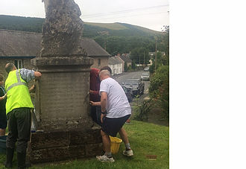
Free training about how to clean and maintain war memorials !
July 20, 2017
The Powys War Memorials Project would like to thank everyone who came to the workshop in New Radnor to find out how to maintain and clean the war memorial.
Please contact the Powys War Memorials Project Officer if you would like to arrange a *free* workshop for your local war memorial.
Warmemorials@powys.gov.uk
01597 827 597

In Memoriam 2014: Free "Smart Water"

July 12, 2017
War Memorials Trust is working in partnership with the SmartWater Foundation on a project called In Memoriam 2014 which will provide greater protection for war memorials in the United Kingdom.

In Memoriam 2014 Smart Water

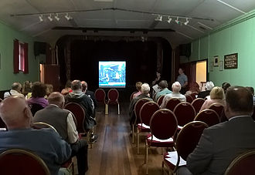
Thanks to everyone who came to or contributed to the free World War 1 event in Presteigne on 7th July 2017
July 10, 2017
The Powys War Memorials Project Officer would like to thank everyone who came to, helped at or contributed to the free World War 1 community event at the Memorial Hall in Presteigne on Friday 7th July 2017.
About 40 people attended.
The event included presentations from Judge's' Lodging Presteigne, Powys Archives and the Welsh Memorials to the Great War Project (Swansea University).
There was also an open session during which people shared memories and stories about how their ancestors were involved in or affected by World War 1.
A student from the local High School also recounted a visit to World War 1 battlefields.
Thank you once again to everyone who came to, helped at or contributed to the event. Your support is greatly appreciated.

Presteigne war memorial restored with funding from the Powys War Memorials Project

July 04, 2017
Summary of how Presteigne war memorial was restored with funding from the Powys War Memorials Project.

Presteigne war memorial case study

Everyone welcome ! FREE World War 1 event: Friday 7th July, 6pm-9pm, Memorial Hall, Presteigne, Powys

July 02, 2017
Powys War Memorials Project
Free World War 1 event

Friday 7th July 2017
6:00pm - 9:00pm (latest)
Memorial Hall, Presteigne, Powys

Although the event is free, donations are welcome for the East Radnorshire Day Centre in Presteigne.

Please feel free to bring World War 1 photographs, newspaper articles, artefacts etc for an open session.

6:00pm Nathan Davies: Powys War Memorials Project Officer

6:10pm Gabrielle Rivers: Judge’s Lodging Presteigne

6:30pm Roz Williamson: Powys Archives (family history research)

6:45pm Jonathan Protheroe:
Stonemason who repaired Presteigne war memorial

7:00pm Break followed by Beverley Baynham (East Radnorshire Day Centre)

7:30pm Meg Ryder:
Swansea University (Welsh Memorials to the Great War Project)

7:45pm Gabrielle Rivers: Judge’s Lodging Presteigne

8:00pm Open session: World War 1 poetry, photographs, stories etc

8:45pm Thanks and close

Free buffet and refreshments provided.
​

FREE World War 1 event !

Powys War Memorials Project competition tie-breakers
June 29, 2017
The 2017 Powys War Memorials Project quiz asked entrants to complete the following tie-breaker in less than 15 words:
​
"It is important to preserve war memorials because...."
​
Here are some of the tie-breakers:
​
-A local physical presence connects yesterday’s sacrifice and a reminder to strive towards peace.

-They are an important part of history, ensuring future generations never forget the sacrifices made.

-They are a physical reminder of people, now long gone, who died for their country.

-They allow us to remember fallen heroes.

-They form part of our cultural heritage through commemoration of those affected by global conflict.

-It is vital to remember the past so we don’t repeat the same mistakes.

-We need to commemorate the lives that were tragically lost in historic wars or conflicts.

-It reminds us to consider how we have the life we lead today.

-Memorials both honour each individual sacrifice and represent a community’s chosen method of remembrance.

-They commemorate those who lost lives and remind us of the devastating impact of war.

-Not only do they provide history they give us a place to reflect on life.

-They commemorate our past, criticise our present and council us for our future.
​
-It is the least we can do in order to remember and honour those heroes.

Here is the winner of the 2017 competition

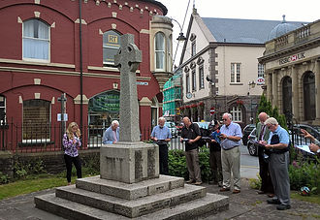

War Memorials Trust training: Video clip of site visit to war memorial outside St Mary's church, Brecon, Powys

June 28, 2017
The Powys War Memorials Project and the War Memorials Trust would like to thank everyone who came to the training in Brecon about how to use the website War Memorials Online:
​
https://www.warmemorialsonline.org.uk/
​
The training included a site visit to the war memorial outside St Mary's church in Brecon.
​
War Memorials Online is an unprecedented opportunity for the public to upload images of war memorials and log concerns for the conservation of these important community and historical sources for future generations. Together, we can build a complete picture of the whereabouts, type and condition of all war memorials in the UK. To date, our Contributors have added over 30,000 war memorials to War Memorials Online and over 20,000 condition reports.
Anyone and everyone can help protect war memorials for future generations. Your content is vital. Register to contribute information or explore the site to find out more about war memorials.

Video of War Memorials Trust training: site visit

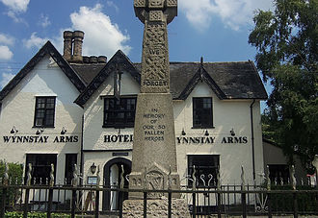

Video of war memorial in Llanrhaeadr ym Mochnant, Powys

June 26, 2017
Fascinating 3 minute video clip on You Tube about the war memorial in Llanrhaeadr ym Mochnant, Powys.
​
www.youtube.com/watch?v=CZKiOKbNNwo

Here is some more information about the war memorial on the Clwyd Family History Society website:

www.clwydfhs.org.uk/cofadeiladau/llanrhaeadrym_wm.htm
​
​
​
​

Fascinating 3 minute video clip on You Tube about the war memorial in Llanrhaeadr ym Mochnant, Powys

War Memorials Trust training
June 25, 2017
The Powys War Memorials Trust was delighted to work with the War Memorials Trust to deliver free training in Brecon last week (22nd and 23rd June 2017) about how to use the website:
​
War Memorials Online
​
We would like to thank the 25 people or so, who came to the training. A quick look at the evaluation forms show that people found the training useful, interesting, relevant and enjoyable.
​
Thanks once again to the War Memorials Trust for coming to Powys to deliver the training.

War Memorials Online

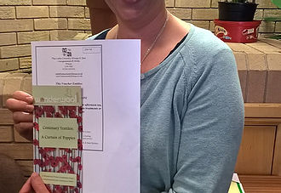

Competition winner announced !
June 11, 2017
The Powys War Memorials Project is delighted to announce that Jo Hammonds is the winner of the 2017 competition !
Jo has won a "My Pamper Day" voucher for the Lake Country House Hotel in Powys worth £95.00.
Jo's winning tie-breaker was:
It is important to preserve war memorials because…….
"Each unique commemorative monument gives insight to sacrifices made by generations never to be forgotten."
Here's photograph of Jo receiving her prize !
Many thanks to everyone who entered the competition.

The Lake Country House Hotel & Spa

Wonderwool Wales: Curtain of Poppies

June 05, 2017
The Powys War Memorials Project is delighted to be supporting the Wonderwool Wales Curtain of Poppies project.
​
Wonderwool Wales would like to bring together textile makers to recreate the united determination of the WW1 volunteers. The aim of the Centenary Textiles project is to produce a Community Textile Installation at Wonderwool Wales 2018 to mark the end of WW1. The 'Curtain of Poppies' will include 887,858 textile poppies, to commemorate each person from the UK who died serving their country.
​
Volunteers are invited to use our range of patterns to make one or more textile poppies to feature in the Curtain of Poppies in 2018. If you or your textile group would like to make a larger contribution, please make lengths of green i-cord (4 stitches) approximately 2 metres long, and stitch pairs of poppies back to back, at a spacing of about 15 cm.
​
​
​
​

Wonderwool Wales Curtain of Poppies

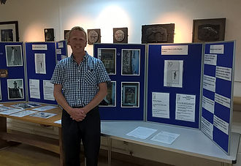

Battle of the Somme film screenings at The Hafren in Newtown, Powys

May 26, 2017
The Powys War Memorials Project Officer (shown in photograph) worked in collaboration with The Hafren Newtown to screen the restored version of the 1916 Battle of the Somme film on Saturday 27th May.
​
In total, about 100 people came to the two free screenings. Here's what some people said when asked how they felt during the film:
​
-Sadness at such a waste of life
-Admiration for the troops
-Amazed by the sheer number of soldiers
-Frightened
-Hopeful
-Regretful
-Empathetic
-Disbelief
​
Thank you to everyone who came to watch the film.

The Hafren Newtown

Llangammarch Wells History Society
May 25, 2017
The Powys War Memorials Project is delighted to be working in collaboration with Llangammarch Wells History Society.
​
​

Llangammarch Wells History Society website

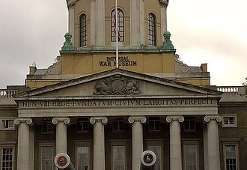

Imperial War Musuems

May 17, 2017
The Powys War Memorials Project is delighted to be working in collaboration with the Imperial War Museums.
​
​

Imperial War Musuems

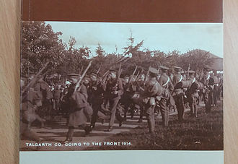

Talgarth's War 1914-1919 (book launch)

May 02, 2017
The Powys War Memorials Project was delighted to support the launch event for the Talgarth and District Historical Society's book "Talgarth's War 1914-1919".
Please contact the Powys War Memorials Project Officer if you would like to discuss World War 1 events and activities in your local community.
Warmemorials@powys.gov.uk
01597 827 597

Talgarth and District Historical Society

Do you know any World War 1 memorials in Powys that need to be repaired or restored?
April 11, 2017
The Powys War Memorials Project can provide grants of up to £5000 to repair, restore or maintain World War 1 memorials in Powys.

Any type of World War 1 memorial is eligible.
​
Quick and easy application process.
​
Please contact the Powys War Memorials Project Officer for more information.
Warmemorials@powys.gov.uk
​
​
​
​

Funding for war memorial repair or restoration

Free World War 1 event: Friday 7th July 2017, 6pm, Memorial Hall, Presteigne
April 10, 2017
Free World War 1 event
Friday 7th July 2017
6pm-9pm
Memorial Hall, Presteigne, Powys

The Powys War Memorials Project would like to invite you to a free World War 1 event.
With presentations from:
Judge's Lodging Presteigne
Powys Archives
Welsh Memorials to the Great War Project
Stonemason who repaired the war memorial in Presteigne
Please feel free to bring World War 1 photographs, newspaper articles, artefacts etc for an open session.
Although the event is free, donations are welcome for the East Radnorshire Day Centre in Presteigne.

Facebook post about the event

Would you like to be considered for war memorial repair, restoration or maintenance work?
April 09, 2017
Can you help?

The Powys War Memorials Project is currently looking for specialists, craftspeople and conservators, who would like to be considered for war memorial repair, restoration or maintenance work.

There are many different types of war memorials, including stone obelisks, crosses and statues, stained glass windows, plaques and boards, benches, paper Rolls of Honour and memorial halls and institutes.

If you have experience in any of the above or in repairing, restoring or maintaining war memorials please contact me.

With thanks
Nathan Davies
Powys War Memorials Project Officer
Warmemorials@powys.gov.uk
​
​
​
​
Talgarth World War 1 walk
April 04, 2017
The Talgarth Walkers are Welcome Group and the Powys War Memorials Project worked together to develop a World War 1 walk around Talgarth.

The 1 mile circular walk (graded as easy) enables you to find out about how men, women and children from Talgarth were involved in and affected by World War 1.
​
The Talgarth walk leaflets (English and Welsh) can be downloaded here.
​
​
​
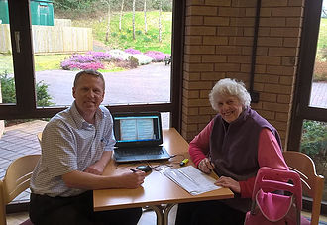
Free training
March 26, 2017
The Powys War Memorials Project can organise or deliver free training about, for example:
​
- How to research names on war memorials using online resources.
- How to record war memorials.
​
Here's a photograph of Nathan Davies (Powys War Memorials Project Officer) helping a local resident find out more about her ancestors' involvement in World War 1.
​
Please contact Nathan Davies (Powys War Memorials Project Officer) for more information about training. You can either email Nathan at warmemorials@powys.gov.uk or phone him on 01597 827 597.
​
​
Powys War Memorials Project free competition !
March 26, 2017
Enter the Powys War Memorials Project free competition to be in with a chance of winning one of four prizes !
​
The four prizes are worth about £200 in total.
​
- Free to enter.
- 10 questions plus tie-breaker.
- Anyone aged 18 years or over can enter.
​
​

Questions and entry form

The Unremembered

March 22, 2017
Big Ideas Community Interest Company is working with the Department for Communities and Local Government (DCLG) on a new community engagement programme The Unremembered, commemorating the bravery and sacrifice of the Labour Corps throughout World War One.
​
http://www.bigideascompany.org/project/the-unremembered/

The Unremembered

The Village Quire: Back to the Garden
March 20, 2017
The Village Quire:
Back to the Garden
​
The Powys War Memorials Project would like to highlight Back to the Garden by The Village Quire:
​
Back to the Garden: A new musical story of life and hope in the trenches of war-torn France during the Great War, from the letters of Corporal William Bevan, soldier and gardener.
​
​
​

Back to the Garden by The Village Quire

Free training !
March 20, 2017
The Powys War Memorials Project can provide *free* training about, for example, how to research names on war memorials.
This is a photograph of the Powys War Memorials Project Officer helping a Powys resident to find information about her ancestors using online resources.
Please contact the Powys War Memorials Project Officer if you would like more information about the free training that can be provided:
Warmemorials@powys.gov.uk
01597 827 597

National Manuscripts Conservation Trust (NMCT)

March 16, 2017
National Manuscripts Conservation Trust (NMCT)
The Powys War Memorials Project would like to highlight the grants that are available from the National Manuscripts Conservation Trust (NMCT).
The NMCT helps preserve important manuscript and archive collections by awarding grants for their conservation. The NMCT has been awarding grants for the conservation of manuscripts since 1991. Between 2010 and the end of 2016 the NMCT awarded grants totalling over £1m.
If you have a World War 1 manuscript, such as a Roll of Honour, which needs repair or restoration work, please contact the Powys War Memorials Project Officer to find out about grant funding opportunities.
Warmemorials@powys.gov.uk

National Manuscripts Conservation Trust

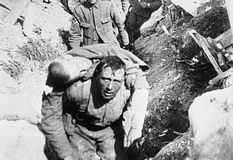

Free screenings of the Battle of the Somme film: Saturday 27th May 2017, 2pm and 7pm, Hafren, Newtown (Powys)

May 26, 2017
Free screenings of the Battle of the Somme film
Saturday 27th May 2017
Two screenings: 2:00pm and 7:00pm
The Hafren Theatre Newtown (Powys)
Free entry for everyone
The Powys War Memorials Project and the The Hafren Theatre Newtown in Newtown (Powys) are working in collaboration to screen the restored Battle of the Somme film.
This year, Imperial War Museums (IWM) and members of the First World War Centenary Partnership are working together to show The Battle of the Somme to audiences across the world. Shot and screened in 1916, it was the first feature length documentary about war and changed the way both cinema and film was perceived by the public. In the year of its release around 20 million people (almost half the population of Britain at the time) watched it, many hoping to see the image of a loved-one, or friend captured on film.
The film is being screened twice on Saturday 27th May 2017 at the The Hafren Theatre Newtown (Powys). The first screening is at 2:00pm, the second screening is at 7:00pm.
Entry is free for everyone.

Battle of the Somme film: Saturday 27th May 2017, Hafren, Newtown, Powys

Powys War Memorials Project quiz is now open !
March 13, 2017
The Powys War Memorials Project 2017 Quiz is now open !
- Free to enter.
- Total prize fund worth about £200 including 1st prize of "My pamper day" Lake Country House Hotel and Spa (Llangammarch Wells, Powys) worth £95.00.
- Ten questions plus tie-breaker.
- All the answers can be found either on the project website or on the Welsh Memorials to the Great War website.
- Closing date: Friday 9th June 2017.
​
Please visit the Powys War Memorials Project website for more information and to download an entry form.
www.powyswarmemorials.co.uk/competitions
​

Quiz information and entry form

Two free screenings of the Battle of the Somme film: Wednesday 15th March 2017, 2pm and 7pm, Wyeside Centre, Builth Wells, Powys
March 15, 2017
Battle of the Somme film

Two free screenings
Wednesday 15th March 2017
2pm and 7pm
Wyeside Arts Centre, Builth Wells, Powys
​
The Powys War Memorials Project and the Wyeside Arts Centre in Builth Wells are working in collaboration to screen the restored Battle of the Somme film.
​
This year, Imperial War Museums (IWM) and members of the First World War Centenary Partnership are working together to show The Battle of the Somme to audiences across the world. Shot and screened in 1916, it was the first feature length documentary about war and changed the way both cinema and film was perceived by the public. In the year of its release around 20 million people (almost half the population of Britain at the time) watched it, many hoping to see the image of a loved-one, or friend captured on film.
The film is being screened twice on Wednesday 15th March 2017 at the Wyeside Arts Centre in Builth Wells. The first screening is at 2:00pm, the second screening is at 7:00pm.
​
Entry is free for everyone.

Evaluation form for Battle of the Somme film (English)

You Tube clip about war memorial in Llanymynech

March 09, 2017
You Tube clip about war memorial in Llanymynech
​
Produced by Stuart Stanton.
​
​

Click Here to go to You Tube clip

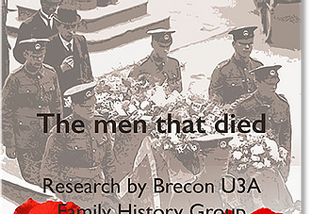

Brecon Remembers World War 1
February 20, 2017
Brecon Remembers World War 1
​
The Family History Group of the Brecon U3A undertook a project to commemorate the centenary of the commencement of World War One, but in choosing the topic they wished it to be both meaningful and useful.
​
The choice was to try and provide a brief biography of all the Brecon men who fell in World War One, as listed on the town's memorial. This was seen as not only a presentation topic, but also the opportunity to provide a useful outcome through the production of this book, and a subsequent website.
​
Prior to this there was little detail readily available and the memorial itself only gives initials and surnames, which after one hundred years is not very useful to researchers, let alone family members and others.
​
The details gathered and produced within this book have been shared with local churches, schools and museums to enhance the process of remembrance, and it is also hoped the book will provide a basic insight into the social and military history of the individuals and their times.
​
​

Brecon Remembers World War 1

2017 Digital Past Conference: Royal Commission on the Ancient and Historical Monuments of Wales (RCAHM)

February 17, 2017
2017 Digital Past Conference:
Royal Commission on the Ancient and Historical Monuments of Wales (RCAHM)
​
The Powys War Memorials Project Officer attended the 2017 Digital Past Conference in Newport, south Wales.
​
Organised by the Royal Commission on the Ancient and Historical Monuments of Wales, Digital Past is an annual two day conference which showcases innovative digital technologies and techniques for data capture, interpretation and dissemination of the heritage of Wales, the UK and beyond. Bringing together individuals from the commercial, public, academic, third sector and voluntary sectors, the conference aims to promote learning, discussion and debate around a range of digital technologies in current use, or in development, to record and understand the historic environment.
​
​
​
​
​

2017 Digital Past Conference

Imperial War Museum Short Film Festival 2017 Call for Entries Now Open

February 08, 2017
Imperial War Museum (IWM) Short Film Festival 2017 Call for Entries Now Open
​
IWM Short Film Festival is a showcase of imaginative and challenging films inspired by our collections and our role – to explore the causes, course and consequences of war and conflict, and its impact on people’s lives.
​
Call for entries for IWM Short Film Festival 2017 closes midnight Friday 28 April 2017.

Entries will be accepted in two categories:
Documentary
Creative Response
There will be four additional awards:
​
IWM Special Category: States of Emergency
Best Student Film
Best Use of IWM Archive Material
Audience Vote Award
All shortlisted films will be screened at IWM London in November 2017. Filmmakers will also be in with a chance of having their film screened at Picturehouse cinemas.
​
Prizes for 2017 include:
An archive and restoration package of up to £10,000 with R3Store Studios Ltd
A 12 week paid internship with October Films
5 days free access to a fully equipped studio space or High End post-production facilities at London South Bank University

Imperial War Museum Short Film Festival

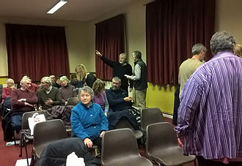

World War 1 event in Llanidloes, Powys
February 02, 2017
The Powys War Memorials Project would like to thank everyone, who contributed to, came to and helped at the World War 1 event in Llanidloes (Powys) on 31st January 2017.
Local historians presented their research about how local families were affected by or involved in World War 1.
We also enjoyed presentations from the Wales at War Project, Powys Archives and a Commonwealth War Graves 'Living Memory' Project.
During an open session at the end of the evening, people showed family artefacts relating to World War 1.
Many thanks are given to the Wesley Singers, who performed a variety of songs and recited some poetry during the event. Please click on the link for a short video clip.
The Powys War Memorials Project is keen to support other local communities to hold World War 1 events. For more information, please contact the Powys War Memorials Project Officer: Warmemorials@powys.gov.uk or on 01597 827 597.

Wesley Singers performing at the World War 1 event in Llanidloes, Powys

Christ Church Welshpool: Remembering the Fallen of The Great War at Christ Church
January 31, 2017
Christ Church Welshpool (Powys)
​
There are many memorials within the church and churchyard dedicated to the fallen of the First World War. To commemorate the centenary of WW1 we will be exhibiting the stories behind these names. As each anniversary comes throughout 2014 – 2018 we will display that soldiers’ story, therefore the exhibition will grow over the four years.
​
Each of the men have a different story to tell, but their connection is that they are all remembered here at Christ Church.
​
http://www.christchurchwelshpool.co.uk/ww1-memorials/

Click Here

The Story of Fourteen Llanfechain Sons
January 23, 2017
This booklet is intended as a written memorial to all those named on the plaques that are mounted either side of the St Garmon’s Lychgate in Llanfechain (Powys) and to others who saw service in those conflicts. It attempts to put their sacrifice in the context of a changing world and village.
​
Llanfechain and the surrounding area sent 78 men to war from a farming population of about 540. It no doubt also sent horses. Such a loss in man and horse power must have been significant. Those listed in St Garmon’s Church as having served in the First World War are at Annex A. Others who saw service but for some reason were not included on the Church list are also noted. The following pages pay tribute to those who were killed during that war

Acknowledgements
The Lychgate and its war memorial plaques, which together constitute the ‘War memorial’, was built in 1919 in recognition of the sacrifice made by members of the Llanfechain community during the First World War. It was dedicated on 10th August of that year.

This booklet was produced and funded by The Llanfechain War Memorial Trust with
the help of certain long term members of the village and where available the families of
those servicemen named. It has been produced at a time when our country has witnessed
the passing of the last survivors of the First World War and on the 70th anniversary of the
beginning of the Second World War. This then has been our effort to record the sacrifices
made by members of this community nearly one hundred years ago and for the following
thirty years of conflict ending in 1945.

​

The Story of Fourteen Llanfechain Sons

Free screenings of the Battle of the Somme film: Wednesday 15th March 2017, 2pm and 7pm, Wyeside Centre, Builth Wells
Battle of the Somme film screenings
Free entry
Wednesday 15th March 2017
2:00pm and 7:00pm
Wyeside Arts Centre, Builth Wells, Powys
The Powys War Memorials Project and the Wyeside Arts Centre in Builth Wells are working in collaboration to screen the restored Battle of the Somme film.
​
This year, Imperial War Museums (IWM) and members of the First World War Centenary Partnership are working together to show The Battle of the Somme to audiences across the world. Shot and screened in 1916, it was the first feature length documentary about war and changed the way both cinema and film was perceived by the public. In the year of its release around 20 million people (almost half the population of Britain at the time) watched it, many hoping to see the image of a loved-one, or friend captured on film.
​
The film is being screened twice on Wednesday 15th March 2017 at the Wyeside Arts Centre in Builth Wells. The first screening is at 2:00pm, the second screening is at 7:00pm.
​
Entry is free for everyone.
​

Click Here

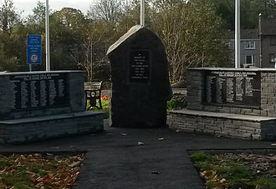
Grants of up to £2700 available to repair, restore or maintain World War 1 memorials in Powys
January 09, 2017
Grants of up to £2700 available to repair, restore or maintain World War 1 memorials in Powys
​
The Powys War Memorials Project can award grants of up to £2700 to repair, restore or maintain World War 1 memorials in Powys.

Any type of World War 1 memorial in Powys is eligible to apply for the funding.
​
Please contact the Powys War Memorials Project Officer if you would like to apply for project funding for your local World War 1 memorial.
​
Photograph of the refurbished war memorial in Ystradgynlais, Powys. The memorial received funding from the Powys War Memorials Project.
​
​
​
​
​
​
​
​
Click Here

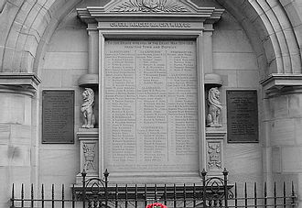

Tuesday 31st January 2017
7:00pm - 9:30pm (refreshments available from 6:30pm)
St Idloes Church Hall, Church Street, Llanidloes, Powys. SY18 6AN
With presentations about:
-Llanidloes and World War 1
-Wales at War Project
-Powys Archives- Family history research
-Commonwealth War Graves Commission Living Memory Project
Entertainment by the Wesley Singers.
Although the event is free, donations are welcome for the
Llanidloes Hospital Palliative Care Unit.
Please feel free to bring World War 1 photographs, newspaper articles, artefacts etc

Click Here

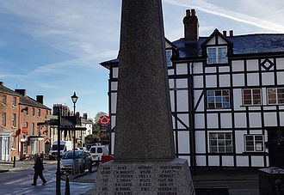
Free training: Researching men and women listed on war memorials

